European Project Semester at ISEP - EPS@ISEP

Project Title
Pet tracker
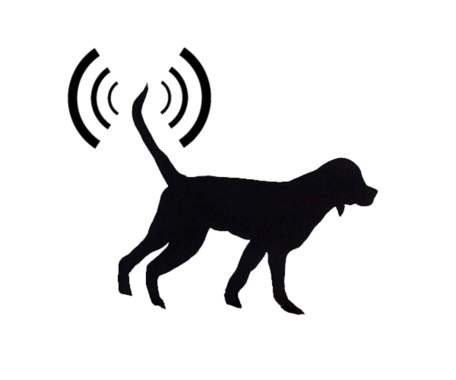

Sponsor

Project Summary
The goal is to design and develop a pet tracker system.
The project requirements are:
- Web interface;
- Display track using Google Maps/Google Earth;
- On board data storage;
- Data download Interface;
- Light, small, portable, wearable device;
- At least 48 h Power autonomy;
- Use open source technologies;
- Comply with the following EU Directives:
  - Machine Directive (2006/42/CE 2006-05-17);
  - Electrical Safety: Low Level Voltage Directive (2006/95/CE 2006-12-12);
  - Restriction of Hazardous Substances (ROHS) in Electrical and Electronic Equipment Directive (2002/95/EC 2003-01-27);
- Mandatory adoption and use of the International System of Units (The NIST International Guide for the use of the International System of Units).

Participants
Institution: Instituto Superior de Engenharia do Porto
Group N.2:
Students:
- Artur Costa
- Aleksandra Borzecka
- Anton Fagerström
- Martí Domènech Gasull
Supervisors:
- António Ferreira da Silva (afs 'at' isep 'dot' ipp 'dot' pt)
- Manuel Santos Silva (mss 'at' isep 'dot' ipp 'dot' pt)
- Maria Benedita Malheiro (mbm 'at' isep 'dot' ipp 'dot' pt)
- Maria Cristina Ribeiro (mcr 'at' isep 'dot' ipp 'dot' pt)
- Nídia Sá Caetano (nsc 'at' isep 'dot' ipp 'dot' pt)
- Paulo Ferreira (pdf 'at' isep 'dot' ipp 'dot' pt)
- Pedro Barbosa Guedes (pbg 'at' isep 'dot' ipp 'dot' pt)
Client:
- José Barros Oliveira (jbo 'at' isep 'dot' ipp 'dot' pt)
Additional Guidelines:
- 2008 ASHRAE Environmental Guidelines for Datacom Equipment

Contents
Work Plan: Deadlines, Tasks, Gantt chart, Task allocation
Logbook: Weekly Report, Meetings, Activities
Report: Report
Deliverables: Links to all deliverables

Contacts
Artur Costa, costa 'dot' ama0 'at' gmail 'dot' com
Anton Fagerström, anton 'dot' fagerstrom 'at' novia 'dot' fi
Aleksandra Borzęcka, aborzecka@poczta.fm
Marti Domenech Gasull, m_domenech91@hotmail.com
EPS@ISEP Group at Facebook

Utilities
- DokuWiki Syntax
- Videos on how to use Wikidoku

Acknowledgements
- ISEP (sponsor)
- Prof. João Correia Lopes
- Eng.º Vítor Costa Cerqueira
— EPS@ISEP Wiki Template 2012/01/15 15:35

