Logbook

Weekly Report

1st Week Report
- The group arranged a meeting in order to get familiar.
- Started assigning tasks to different team members.
- Discussed a few ideas about marketing plans.

2nd Week Report
- The first official meeting with the supervisors took place
- Task allocation and Gantt Chart was done
- Searching for components and materials already in progress
- Discussion about suggested ideas and advice which appeared during the 1st official meeting

3rd Week Report
Things that happened this week:
- Research on modules and materials continued
- First flowchart was created
- First draft of a logo was created
- First draft of leaflet was created
- Ethical code concerning our teamwork was set up and signed by teammembers
- Tried to find an appropriate market for the final product

4th Week Report
Things that happened this week:
- Leaflet was handed in
- Marketing plan was handed in
- List of material was handed in
- Spoke to client

5th Week Report
During our Eastern holiday week we:
- Started the state of the art
- Started to design webpage
- Started to modify a scrum document for project management, so that we can use one in the future.

6th Week Report
Things that happened this week:
- We started to insert more info to the report sub-page on the wiki
- We finished the scrum excel file and are now able to use it for project management.
- We updated the gantt chart so that it matched the scrum file.
- We started to modify the existing marketing plan for the interim report.
- We started to write the sustainability and ethics part for the interim report

7th Week Report
Things that happened this week:
- Leaflet was updated according to Anas' comments.
- All separate documents were compiled into a interim report document.
- Presentation for interim report was created.
- All deliverables were uploaded to the wiki.

8th Week Report
Things that happened this week:
- Team prepared for the interim report presentation.
- Presentation was held.
- Feedback was received.

9th Week Report
Things that happened this week:
- We started to modify the report accoding to the comments that we received.

10th Week Report
Things that happened this week:
- We updated the marketing plan with an action prgramme and budget. We are still waiting for feedback from Andreia Gama.
- Schematics were updated.

11th Week Report
Things that happened this week:
- Asked for feedback for the deonotolgy & sustainability part.
- Started working on the poster
- Created first drafts of flow charts

12th Week Report
Things that happened this week:
- We received some parts of the order
- Feedback for marketing plan was received.

13th Week Report
Things that happened this week:
- Soldered the GSM breakout board
- We received some parts
- Feedback for deontology part was received.
- Deontology part was finalized

14th Week Report
Things that happened this week:
- Finalized sustainability part of final report
- Finalized marketing part of final report
- Finalized state of the art part of final report
- Compiled final report
- Created final presentation
- Website went online
- 3D renders of prototype were done
- Paper was written
- Started to write user manual
- Final delivery of component order was delivered

Meetings

1st Meeting (2013-03-01)

Agenda:
- Presentation
- Modus operandi
- Project proposal
- Electronic Logbook

Minute:
- A team familiarized with the Wiki Page
- Project topic was chosen
- The first discussion about the project took place
- A list of suggested questions for the first official meeting with supervisors was created

2nd Meeting (2013-03-07)

Agenda:
- Presentation of team
- Communication/Communication module
- Power supply
- Data storage
- Weight
- Suppliers
- Radiation/ radiation control
- Materials

Minute:
It was decided that we should:
- Create a list of devices/modules that meet the requirements
- Insert all attributes from devices into a list for easy comparison (power consumption, price and dimensions have to be taken into consideration)
- Check allowed levels of radiation, temperature etc. for pets as well as for humans
- Get Pro-form invoice from chosen supplier. Get VAT from Benedita
- Develop web interface in Linux. App for Android
- Figure out how to minimize the power consumption
- Define detailed scope of product
Other suggestions:
- Product as “clip-on” or collar (the matter of weight)
- Client's name is José Barros Oliveira

3rd Meeting (2013-03-14)

Agenda:
- Considerations about prototype
- Battery/battery charging module
- Battery step-up regulator
- Using the GSM/GPRS module
- Using the GPS module
- Standalone chip(PIC/AVR) vs arduino
- Suppliers restrictions
- Mobile Website vs Mobile App

Minute:
It was decided that we should:
- Create a “Top to bottom” agenda list next time.
- Create a Block diagram and add contents to it.
- Add logging to flowchart
- Choose if update interval should be fixed or adaptive.
- Investigate in FSK modules. Might need external antennas.
- Define final test requirements.
- Check with G7electronica 800 102 037 if they can agree upon paying after receiving materials
- Create a list as Manuel suggested.
Other suggestions/comments:
- Modes: Sleep mode when no activity. Wake up when activity resumes.
- Suppliers: Inmotion, Farnel

4th Meeting (2013-03-21)

Agenda:
- Tracking system integration
- Q2686 Module(Antenna, Mechanical Integration, Programming)
- XM0110 Module(Antenna, Mechanical Integration)
- GSM/GPRS to webserver

Minute:
- General considerations about the the Q2686 and XM0110 modules
- A transparent connection must be established between the communication module and the server

5th Meeting (2013-04-05)

Agenda:
- Interim report(What to expect, guidelines, suggestions)
- Interim Presentation
- Building the pet tracker

Minute:
- Supervisors explained how the report and the presentation should be structured.
- They also showed us where to find templates for the required documents.

6th Meeting (2013-04-11)

Agenda:
- General considerations about the report

Minute:
- Supervisors commented on some of the things for our report.
- Meeting was short due to lack of topics on the agenda.

7th "Meeting" (2013-04-11)

Agenda:
- Interim presentation

Minute:
- Presentation
- Discussion

8th Meeting (2013-04-26)

Agenda:
- Power Supply design - evaluation of the current design
- Programming the Arduino Pro Mini

Minute:
It was decided that we should:
- check the feedback from other professors about the report
- think about the switching regulators
- look for some regulators modules - there exist better suggestions than we found
- think about users' manual
- prepare more detailed signal schemating and drawings

9th Meeting (2013-05-02)

Agenda:
- Status update on the components.
- What happens if we are not allowed to buy the components.
- Tasks to fulfill for the next days/weeks (what to do until we get the components?).

Minutes:
It was decided that we should:
- specify as much as possible all schematics
- keep on working with the web interface
- start programming soon

10th Meeting (2013-05-09)

Agenda:
- 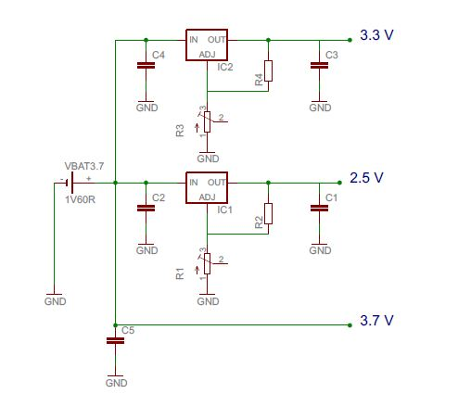
- Some more pictures

Minutes:
- Rethink power diagram. Use more simple solution.

11th Meeting (2013-05-16)

Agenda:
- 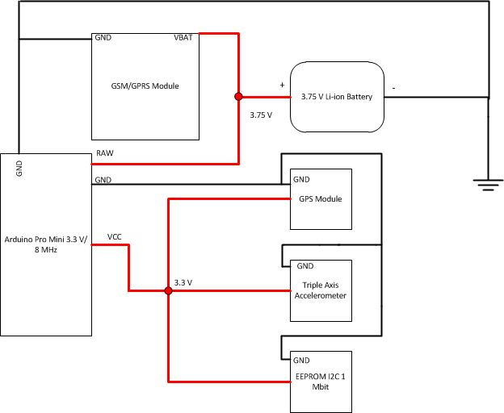

Minutes:
It was decided that we should:
- think about a current booster in our diagram
- meet with Mr. Joao Fransisco Silva to discuss few things connected with plastic container
- consider different types of container in Marketing Plan

12th Meeting (2013-05-23)

Agenda:
- Using a mobile phone as a GSM modem
- Getting data from Nokia PC Suite

Minutes:
- Do not use Nokia PC suite.
- Supervisors gave suggestions about using GPRS instead of SMS.

13th Meeting (2013-05-30)

Agenda:
* Are the following flowcharts ok?:
- General function flowchart
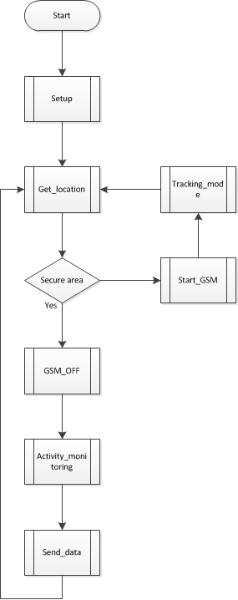
- Activity monitoring flowchart
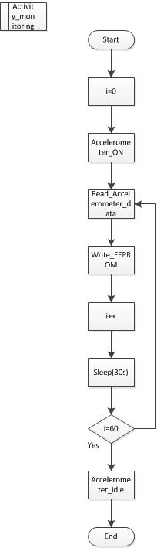
- Get location flowchart
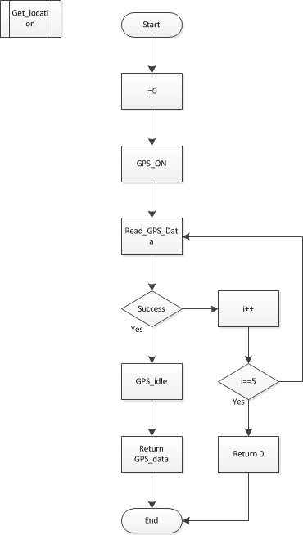
- Start GSM module flowchart
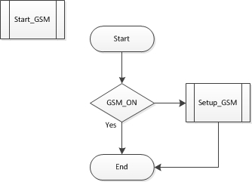

Minutes:
- relating to the 1st general flowchart, we should think about reading 2 sensors in the same time
- second and third charts should be re-done
- suggestion to the activity monitoring chart - we should think about minimizing numbers of writes (make some average values to make the data more smooth and useful to read)

14th Meeting (2013-06-06)

Agenda:
- Pushed deadlines?
- Time limits for presentation?
- How exactly the final presentation should look like?

Minutes:

Activities
Please register here all project activities
Start | End | Task | Description | Who
1.3.2013 | 3.3.2013 | Choose project | - | All
1.3.2013 | 7.3.2013 | Assign tasks to team members | - | All
10.3.2013 | 10.3.2013 | Hand in task allocation chart |  | All
15.3.2013 | 18.3.2013 | Create leaflet | - | Anton & Ola
1.3.2013 | 20.3.2013 | Research modules | - | Artur
1.3.2013 | 21.3.2013 | Make list of materials | - | All
19.3.2013 | 19.3.2013 | Spread questionnaire on social medias | - | All
20.3.2013 | 21.3.2013 | Researching the modules specifications | - | Artur
21.3.2013 | 21.3.2013 | Create Marketing Plan | - | Anton & Ola
24.3.2013 | 25.3.2013 | Update the list of materials | - | Artur
4.4.2013 | 4.4.2013 | Create a workplan (product and sprint backlog) | - | Anton
4.4.2013 | 5.4.2013 | Updated gantt chart | - | Anton
5.4.2013 | 6.4.2013 | Start defining use cases | - | Marti
8.4.2013 | 10.4.2013 | Updated sustainability and ethics part | - | Ola
8.4.2013 | 12.4.2013 | Interim report | - | All
12.4.2013 | 13.4.2013 | Interim report revision | - | Anton and Artur
12.4.2013 | 13.4.2013 | Finish smartphones market analysis | - | Marti
13.4.2013 | 14.4.2013 | Start designing power diagrams | - | Artur
22.4.2013 | 22.4.2013 | Create new template for final report | - | Artur
29.4.2013 | 2.5.2013 | Improving the report | - | Artur
1.5.2013 | 5.5.2013 | Updating Marketing Plan | - | Anton & Ola
5.5.2013 | 6.5.2013 | Defining final tests | - | Marti
9.5.2013 | 9.5.2013 | Power supply redesign | - | Artur
21.5.2013 | 22.5.2013 | Flowchart revision | - | Artur
22.5.2013 | 23.5.2013 | Finalize the Ethics part of the report | - | Ola
23.5.2013 | 28.5.2013 | Assembling and programming the GSM module and EEPROM | - | Artur
18.5.2013 | 30.5.2013 | Finalize Marketing Plan | - | Anton
4.6.2013 | 4.6.2013 | Finalize poster | - | Anton
4.6.2013 | 4.6.2013 | Render 3D image of prototype | - | Anton
4.6.2013 | 4.6.2013 | Update logbook on wiki page | - | Anton
4.6.2013 | 4.6.2013 | Finalize the Sustainability part of the report | - | Ola
4.6.2013 | 4.6.2013 | Start creating the video | - | Ola

Material List
Product | Link | Description | Quantity
GPS | https://www.sparkfun.com/products/8234 | EM-408 with Antenna/MMCX | 1
Arduino | https://www.sparkfun.com/products/11114 | Arduino Pro Mini 328 - 3.3V/8MHz | 1
Battery | http://pt.rs-online.com/web/p/paquetes-de-baterias-de-litio-recargables/5306325/ | ENIX 3,7V 1840mAh | 1
GPRS/GSM | https://www.sparkfun.com/products/10138 | ADH8066 | 1
GPRS/GSM Board | https://www.sparkfun.com/products/10497 | ADH8066 Breakout | 1
Charger | https://www.sparkfun.com/products/10401 | LiPo Charger Basic - Mini-USB | 1
Antenna(GSM) | http://pt.rs-online.com/web/p/antenas-gsm-y-gprs/7043417/ | GSMMQB - Mini Quad Band Antenna | 1
Accelerometer | https://www.sparkfun.com/products/10955 | Triple Axis Accelerometer Breakout | 1
Memory | http://pt.rs-online.com/web/p/chips-de-memoria-eeprom/0454145/ | I2C EEPROM - 1Mbit | 1

